1. Write a C program that takes two integer values as input from the user. Then swap the values

taken from the user and display the output of the variables.

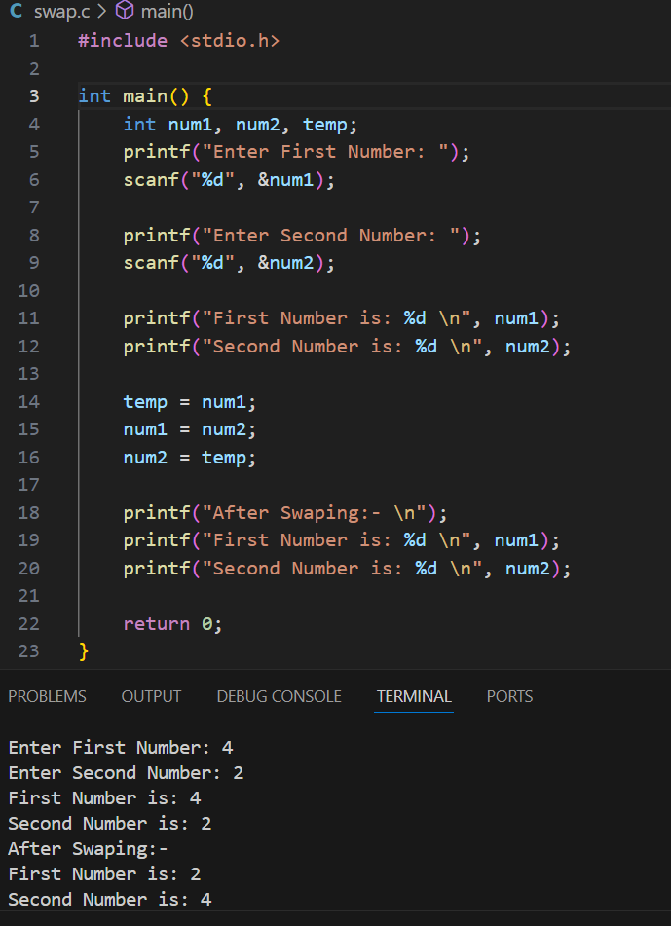

1. A customer asks the IT firm to develop a program in C language, which can take tax rate and

salary from the user on runtime and then calculate the tax, the user has to pay and the salary

he/she will have after paying the tax. This information is then provided to the user.

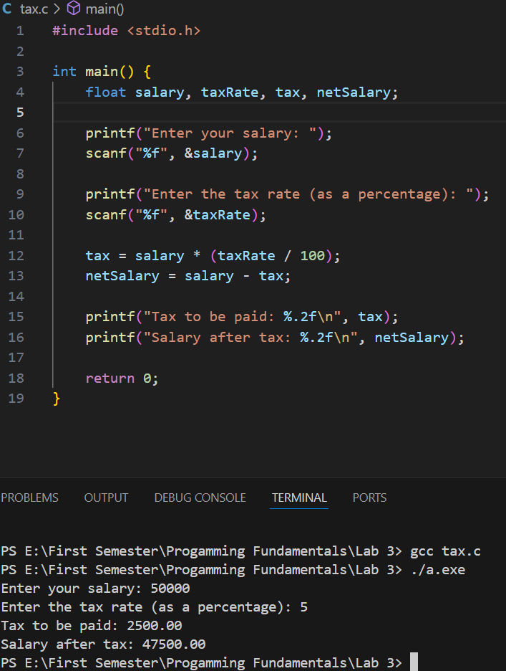

1. A car traveled for some hours. The time car traveled is taken at run time of the program, and it

must not be negative and must be between one to five hours. The car had not traveled same

distance in each hour. The distance that the car covered must not be negative. Write a C Program

that computes the Average Speed of the Car in miles per hour. Hint: the restrictions can be

displayed in the form of message on the window.

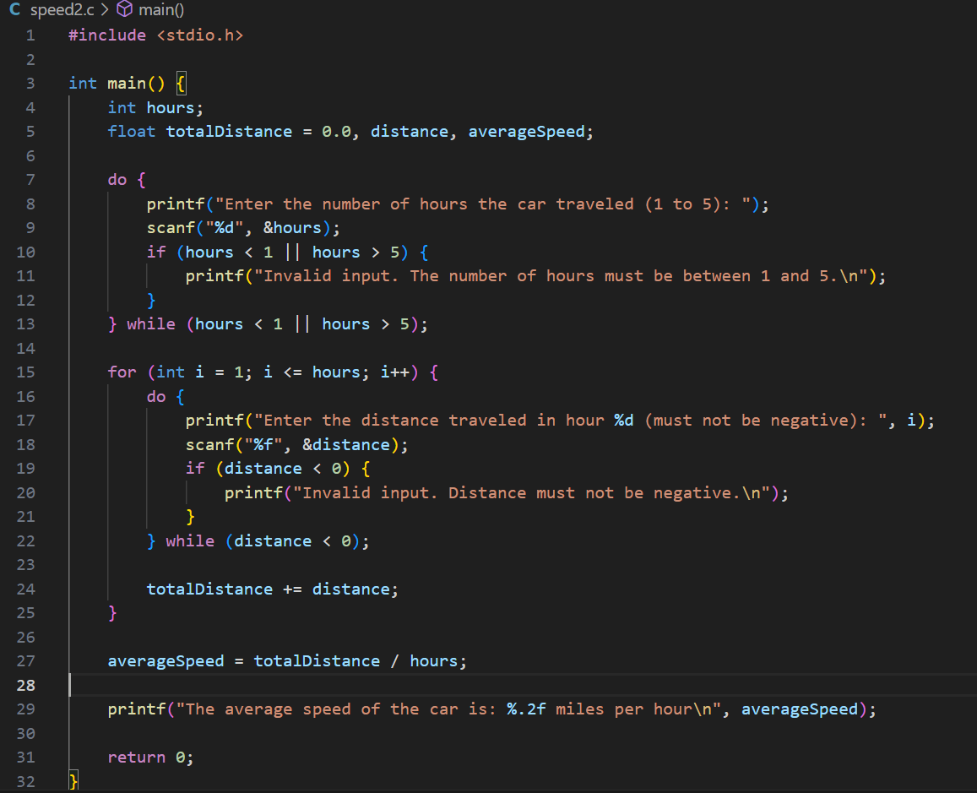

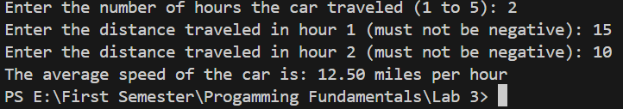

1. Explain the output of this C program. Why the wrong value is being displayed in the output?

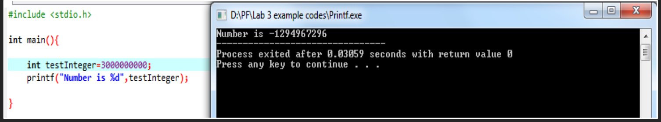

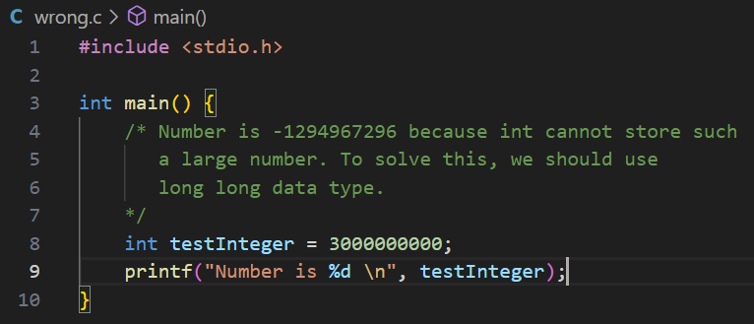

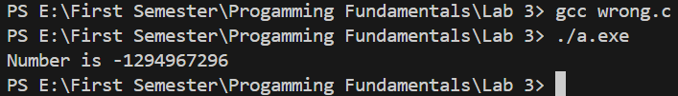

1. Construct a C program with the flowchart below. The input value of the Principle must be

between 100 Rs. To 1,000,000 Rs. The Rate of interest must be between 5% to 10% and Time

Period must be between 1 to 10 years. Hint: these restrictions can be displayed in the form of

message on the window.

